SIMATS ENGINEERING
CO2_ASSESSMENT TOOL3_ Dry Run Evaluation

COURSE NAME: Artificial Intelligence COURSE CODE: CSA1712

Register Number | 192411102
Name | Ayyan Abhisheshan

COURSE OUTCOME COVERED

CO2: Experiment search and game-solving techniques such as Greedy Search, A*, CSP, Minimax, and Alpha-Beta pruning with heuristic functions for solving complex AI problems efficiently. (BL3)

Assessment Tool Weightage: 20%

QUESTIONS: 5 Total Marks:50

Q1. Consider a suitable state-space graph (with heuristic values h(n) assigned to each node) of your choice for a given problem. Perform a dry run of Greedy BestFirst Search from the start node to the goal node. Clearly show the frontier/open list, the node selected for expansion at each step, and the final path obtained.

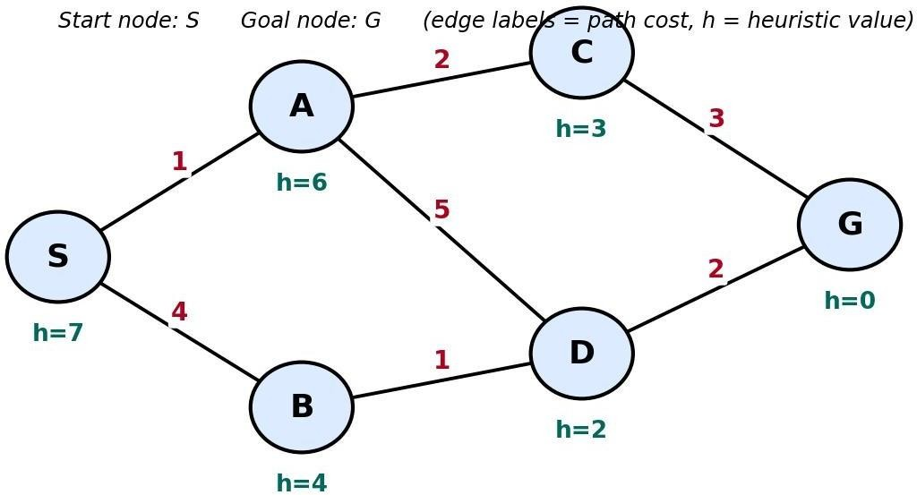

Q2. For a suitable weighted state-space graph (with edge costs and heuristic values h(n)) of your choice, perform a dry run of A* Search from the start node to the goal node. Show the g(n), h(n) and f(n) values computed at every step, the order in which nodes are expanded, and the final optimal path along with its total cost.



Q3. Formulate a given Constraint Satisfaction Problem (e.g., Map Colouring / NQueens) by clearly stating the variables, their domains, and the constraints involved. Perform a dry run of the Backtracking Search algorithm, showing each variable assignment, every constraint check, and any backtracking steps, until a complete solution (or failure) is reached.

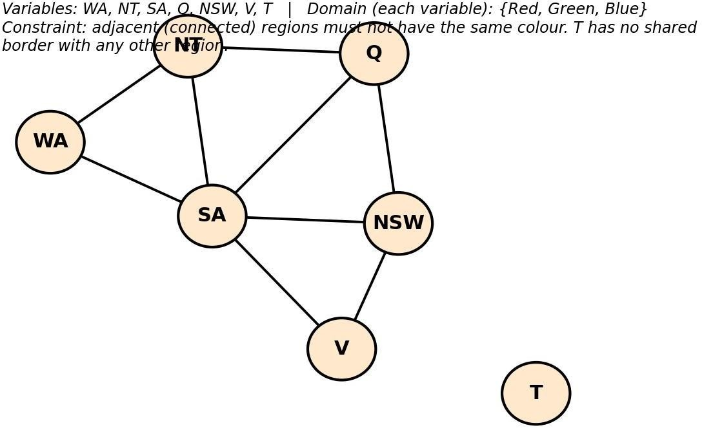

Q4. For a given two-player game tree of your choice (at least 3 levels deep), perform a dry run of the Minimax algorithm. Show the utility values at the leaf/terminal nodes and the backed-up values computed at every internal node, and state the best move for the MAX player with justification.
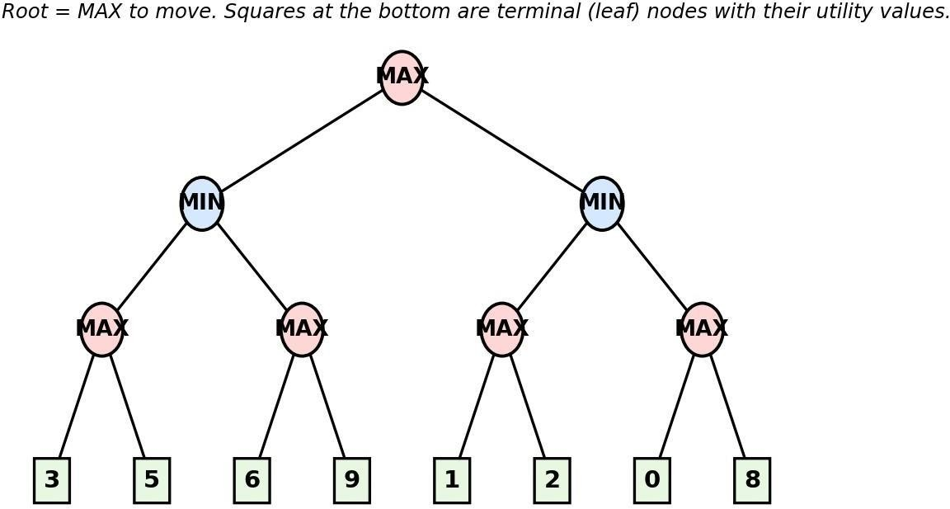

Q5. Using the same (or a different) game tree from Q4, perform a dry run of the Minimax algorithm with Alpha-Beta Pruning. Show the α and β values maintained at each node during the traversal, clearly indicate which branches get pruned and why, and state the final best move obtained.


Code of Conduct:
I Ayyan Abhisheshan(192411102) certify that this submission is my original work and that I have adhered to the guidelines specified for this assessment.
I understand that any violation of academic integrity rules will result in disciplinary action.
Signature of the student
Dry Run Evaluation

RUBRICS FOR CALCULATION

Criteria | Level 4 – Exemplary | Level 3 – Proficient | Level 2 –  Developing | Level 1 – Beginning | Max Marks
Problem  Formulation  & Setup  (states/nodes  , heuristic values or CSP variables,  domains and  constraints correctly identified) | Accurately identifies all required  elements  (states, heuristics/cost s, or  variables/dom  ains/constraint  s) with clear, correct notation. | Identifies most  required  elements  correctly,  with only minor  omissions or  notational  errors that do not  affect the dry run. | Identifies some  required  elements;  noticeable errors or missing  components affect the later steps. | Little or no correct problem formulation; required  elements are  largely missing or incorrect. | 10
Correct  Application of  Algorithm  Procedure  (expansion order,  backtracking,  or pruning as per the  standard method) | Follows the exact  algorithmic  procedure at  every step with  no deviation from the  standard method. | Follows the procedure correctly for most  steps, with  only one or two minor deviations  that do not change the outcome. | Several steps deviate from the correct procedure,  though the overall  approach is recognisable. | Algorithm steps are largely  incorrect, or the procedure is not followed. | 10
Accuracy of  Computations  (g(n), h(n), f(n) values, minimax  backed-up  values, or α–β updates) | All computed values are  accurate and consistent  throughout the dry run. | Minor calculation errors are  present but do not  significantl  y affect the final outcome. | Multiple calculation errors are  present that affect the  correctness  of  intermediate steps. | Calculations are mostly  incorrect or missing. | 10
Criteria | Level 4 – Exemplary | Level 3 – Proficient | Level 2 –  Developing | Level 1 – Beginning | Max Marks
Correctness of Final  Outcome  (final path, CSP solution, or best move obtained) | Final result is completely  correct and  matches the  expected optimal outcome. | Final result is mostly correct,  with only a minor  deviation from the optimal outcome. | Final result is only partially correct. | Final result is incorrect or not obtained. | 10
Clarity of  Presentation  & Justification  (trace tables/trees/ diagrams,  explanation of each step) | Dry run is presented  clearly using  well-organised  tables/trees/di  agrams, with every step  explained and justified. | Dry run is reasonably  clear and mostly  organised,  with minor gaps in  explanation  . | Dry run presentation  is unclear or poorly  organised,  with limited justification. | Dry run is disorganised or  illegible, with little to no justification. | 10
 |  |  |  | Total | 50

Q1. Greedy Best-First Search — Dry Run Problem Setup
Consider the following state-space graph with start node S and goal node G. Each node carries a heuristic estimate h(n) — the straight-line/estimated distance to the goal. Greedy BestFirst Search always expands the node in the frontier with the lowest h(n), ignoring the path cost already incurred.

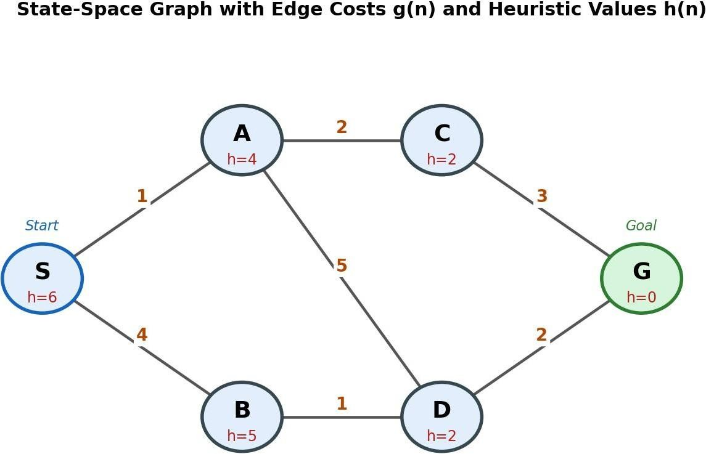
Heuristic table (estimated distance to goal G):

Node | S | A | B | C | D | G
h(n) | 6 | 4 | 5 | 2 | 2 | 0
Dry Run Trace
At every step, the node with the smallest h(n) in the frontier is selected for expansion. Ties are broken alphabetically.

Step | Node Expanded | Frontier (Open List) after expansion — sorted by h(n) | Goal Reached?
1 | S (h=6) | A(4), B(5) | No
2 | A (h=4) | C(2), D(2), B(5) | No
3 | C (h=2) | G(0), D(2), B(5) | No
4 | G (h=0) | — (goal popped from frontier) | Y es — STOP

Result
Final path: S → A → C → G
Path cost (for reference only — Greedy Search does not use this value to guide the search):
g(S→A) +g(A→C) +g(C→G) = 1 + 2 + 3 = 6.

Q2. A* Search — Dry Run Problem Setup
We reuse the same weighted state-space graph (edge costs and heuristic values shown below) so the two searches can be directly compared. A* expands the node with the lowest f(n) = g(n) + h(n), where g(n) is the true cost from the start accumulated so far and h(n) is the heuristic estimate to the goal.



Edge costs: S–A=1, S–B=4, A–C=2, A–D=5, B–D=1, C–G=3, D–G=2
Heuristics: h(S)=6, h(A)=4, h(B)=5, h(C)=2, h(D)=2, h(G)=0

Dry Run Trace — g(n), h(n), f(n) at every step

Step | Node  Expanded | Children Generated → g(n),  h(n), f(n)=g+h | Frontier after  step (sorted by  f)
1 | S  (g=0,h=6,f=6) | A: g=1, h=4, f=5 B: g=4, h=5, f=9 | A(5), B(9)
2 | A  (g=1,h=4,f=5) | C: g=3, h=2, f=5 D: g=6, h=2, f=8 | C(5), D(8), B(9)
3 | C  (g=3,h=2,f=5) | G: g=6, h=0, f=6 | G(6), D(8), B(9)
4 | G  (g=6,h=0,f=6) | Goal test passed — lowest f(n) in frontier and it is the goal node | STOP
Result
Optimal path: S → A → C → G
Total optimal path cost g(G) = 1 + 2 + 3 = 6.
Optimality check: the only alternative complete path is S → B → D → G, with cost 4 + 1 + 2 = 7. Since 6 < 7, A* has correctly returned the least-cost path — confirming optimality, which holds here because h(n) is admissible (never overestimates the true remaining cost, e.g. h(C)=2 ≤ actual cost 3 to G).

Question 3: CSP Formulation and Backtracking Search Dry Run

A Constraint Satisfaction Problem (CSP) consists of variables, domains, and constraints. The objective is to assign values to all variables such that every constraint is satisfied. The Backtracking Search algorithm assigns values sequentially and backtracks whenever a constraint is violated.

Problem Formulation

Variables
{WA, NT,SA,Q,NSW,V,T} Domain

Each region can be assigned one of the following colours:
{Red,Green,Blue}

Constraints

Adjacent regions must have different colours.

WA → NT, SA
NT → WA, SA, Q

SA → WA, NT, Q, NSW, V
Q → NT, SA, NSW
NSW → SA, Q, V
V → SA, NSW
T → No adjacent regions

Backtracking Search (Dry Run)

Step | Assignment | Constraint Check
1 | WA = Red | No conflict
2 | NT = Red | Same as WA
 | NT = Green | Valid
3 | SA = Red | Same as WA
 | SA = Green | Same as NT
 | SA = Blue | Valid
4 | Q = Red | Different from NT and SA
5 | NSW = Red | Same as Q
 | NSW = Green | Valid
6 | V = Red | Different from SA and  NSW
7 | T = Red | No adjacent regions

Final Solution

Region | Colour
WA | Red
NT | Green
SA | Blue
Q | Red
NSW | Green
V | Red
T | Red

The Australia Map Colouring problem is solved using the Backtracking Search algorithm. The algorithm assigns colours one by one, checks all constraints, and backtracks whenever a conflict occurs.

Question 4: Minimax Algorithm - Dry Run
Game tree used (matching the figure): Root = MAX to move, 3 levels deep, with terminal
(leaf) utility values, read left to right, of: 3, 5, 6, 9, 2, 2, 0, 3.
The Minimax algorithm is an AI search algorithm used in two-player, zero-sum games. It assumes that MAX tries to maximize the utility value, while MIN tries to minimize it. The algorithm evaluates the game tree from the leaf nodes upward to determine the optimal move.

Game Tree

Leaf node utility values:

Left Subtree: (3, 5), (6, 9)

Right Subtree: (1, 2), (0, 8)

Step 1: Evaluate MAX Nodes

MAX Node | Leaf Values | Selected Value
MAX₁ | 3, 5 | 5
MAX₂ | 6, 9 | 9
MAX₃ | 1, 2 | 2
MAX₄ | 0, 8 | 8

Step 2: Evaluate MIN Nodes

MIN Node | Children Values | Selected Value
Left  MIN | 5, 9 | 5
Right  MIN | 2, 8 | 2

Step 3: Evaluate Root MAX Node
Root MAX Children Values Selected Value
MAX 5, 2 5

Backed-Up Game Tree
MAX (5)
/ \
MIN (5) MIN (2)
/ \ / \
MAX(5) MAX(9) MAX(2) MAX(8)
/ \ / \ / \ / \
3 5 6 9 1 2 0 8
Dry Run Summary

Step | Operation | Result
1 | MAX(3,5) | 5
2 | MAX(6,9) | 9
3 | MIN(5,9) | 5
4 | MAX(1,2) | 2
5 | MAX(0,8) | 8
6 | MIN(2,8) | 2
7 | MAX(5,2) | 5

The MAX player chooses the left subtree because it guarantees the highest utility value (5) after considering the optimal moves of the MIN player.

The Minimax algorithm evaluates the game tree from the leaf nodes to the root. The optimal utility value obtained is 5, so the left branch is the best move for the MAX player.

Q5. Minimax with Alpha-Beta Pruning — Dry Run

Alpha–Beta Pruning is an optimization technique for the Minimax algorithm. It reduces the number of nodes evaluated by pruning branches that cannot affect the final decision. Here:

α (Alpha): Best value MAX can guarantee.
β (Beta): Best value MIN can guarantee.
A branch is pruned when α ≥ β.

Game Tree

Leaf node utility values:

Left Subtree: (3, 5), (6, 9)

Right Subtree: (1, 2), (0, 8)

Traversal is performed from left to right.

Dry Run with Alpha–Beta Pruning

Step 1: Root (MAX)

α = −∞ β = +∞ Explore the left subtree.

Step 2: Left MIN Node

α = −∞ β = +∞
First MAX Node
Leaf values: 3, 5
MAX = 5

MIN updates:

β = min(+∞, 5) = 5

Second MAX Node
Current values:
α = −∞

β = 5

Evaluate first leaf:
Leaf = 6
MAX updates:

α = max(−∞, 6) = 6 Since
α (6) ≥ β (5)

➡ Prune the next leaf (9).
MAX returns 6. MIN chooses min(5,6) = 5 Return 5 to the root.
Root updates:
α = max(−∞,5) = 5

Step 3: Right MIN Node

Current values:

α = 5 β = +∞ First MAX Node
Leaf values:
1,2

MAX = 2

MIN updates:

β = min(+∞,2) = 2 Now,
α (5) ≥ β (2)

➡ Prune the entire right MAX subtree (0,8).
MIN returns 2.

Step 4: Root MAX

Receives
Left = 5
Right = 2 MAX selects max(5,2) = 5 Alpha–Beta Values

Node α | β | Value Returned
Root MAX 5 | +∞ | 5
Left MIN −∞ | 5 | 5
Left MAX 5 | +∞ | 5
Second MAX 6 | 5 | 6 (Pruned)
Right MIN 5 | 2 | 2
Third MAX 2 | +∞ | 2
Fourth MAX Pruned Pruned Not Evaluated

Pruned Branches
Pruned Branch Reason
Leaf node 9 α = 6 ≥ β = 5 Entire subtree (0, 8) α = 5 ≥ β = 2

Final Result
Root Values Best Value
Left = 5 5
Right = 2

Best Move for MAX: Left Subtree

Using Alpha–Beta Pruning, unnecessary branches (9) and (0, 8) are pruned because they cannot influence the final decision (α ≥ β). This reduces the number of nodes evaluated while producing the same optimal result as the Minimax algorithm. Therefore, the best move for the MAX player is the left subtree with a utility value of 5.

